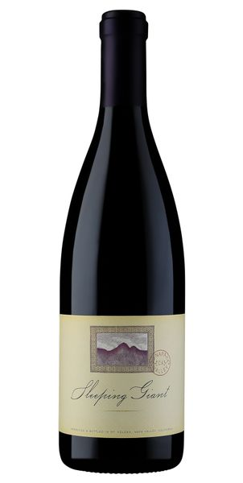
2022 Sleeping Giant Pinot Noir, Dearden Vineyard

Tasting Notes
The 2022 vintage of Sleeping Giant Pinot Noir evokes notes of cherry pie filling, rich, ripe loganberries, baked pie crust and warm cinnamon spices on the nose. There are hints of raspberry streusel, muddled cherries, lilac and notes of red velvet cake that embrace the palate. This wine has structured tannin, subtle yet savory depth, as well as elegant and balanced acidity. Enjoy this wine with seared Ahi Tuna and Petaluma Duck. This is refinement and luxury at it’s finest!
Winemaking
The 2022 vintage marks 16 wonderful years that the 5 clones of Pinot Noir that are blended to create Sleeping Giant Pinot Noir have been happily planted on our property here in Carneros. We have long boasted that due to our vineyard location, in an area rich with diatoms and crushed oyster shells from millennia ago, our 16 year old Pinot Noir vines have been set up for success.
Vineyard
The Dearden Vineyard is located on a 12-acre parcel on Las Amigas Road in the heart of the Napa-Carneros region of Napa Valley where our winery is located. It is the coolest climate area in the Napa Valley and is the birthplace of some of the finest Chardonnays and Pinot noirs produced anywhere in the world. This vineyard was planted in 2006 and is now channeling the full flavor and aroma profile that will continue for decades. The clonal selections of Pinot noir are integral to producing a wine of depth, texture and character. The five clones we planted (115, Pommard, 667, 459 and Calera) were selected for their ability to craft a single vineyard wine from several distinct clones. Yields on this high quality vineyard average a meager 2 tons per acre.
Technical Details
Brix at Harvest: 23.8-25.9
Finished pH: 3.58
Finished TA: 5.7 g/L
Varietal: 100% Pinot Noir
Vineyard Location: Los Carneros, Napa Valley

