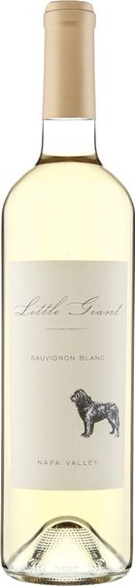

2022 Little Giant Sauvignon Blanc

Vineyard & Winemaking
The traditional gap between the white and red wine harvests nearly vanished, maintaining a frenetic pace until the rains granted winemakers a much-needed reprieve. Subsequent to the rainfall, grapes left to mature through October benefited from mild weather conditions, enabling winemakers to patiently await optimal ripeness. This wine was fermented in stainless steel tanks, and then aged in Dolce barrels for two months Tasting Notes This wine boasts a roundness and full-body while still retaining the bright lively pear, melon and honeysuckle we expect in Sauvignon Blanc.

Technical Details
Brix at Harvest: 23.1
Finished pH: 3.29
Finished TA: 6.30
Varietals: 100% Sauvignon Blanc
Vineyard Location: Hedgeside Ave., Napa Valley

