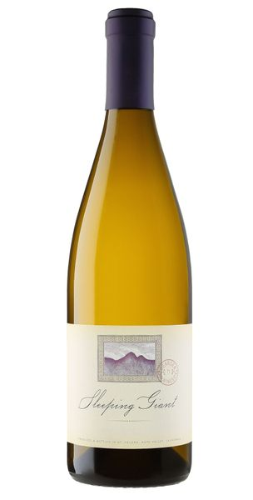
2022 Buena Tierra Chardonnay

Tasting Notes
This chardonnay illustrates a wondrous air of magnolia and French pear at first, followed by scents of clove and ginger. Honeysuckle and Ecuadorian vanilla embrace the palette, while the finish leaves you longing for another glass.
Winemaking & Vineyard
The 65-year-old vines nestled in the Buena Tierra vineyard have long boasted some of the most heralded chardonnay produced in the Russian River Valley, and 2022 was no exception. The Russian River has been renowned for great Chardonnay and Pinot noir for decades due to the cobbly, loamy soils and foggy, cool growing seasons. Buena Tierra is a hallmark vineyard from which this Sleeping Giant Chardonnay emanates. The fruit on these old vines, which were planted upwards of 50 years ago, yield excellent flavors and aromas.This vintage saw a foggy, cool growing season ideal for retaining plenty of acid in each of the tantalizing berries that these stingy vines produce.
Technical Details
Brix at Harvest: 24.1
Finished pH: 3.63
Finished TA: 5.58
Varietal: 100% Chardonnay
Vineyard Location: Russian River, Sonoma County

