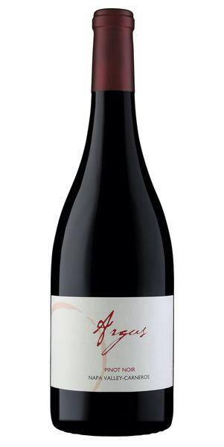
2022 Argus Pinot Noir

Tasting Notes
On the nose you will find hints of dried and crushed cranberries, followed by enticing notes of cherry cola and devils food cake. Rich bing cherry dances on the palate, while cinnamon and clove warm the senses and develop into a voluptuous finish.
Winemaking
The 2022 vintage of Argus Pinot Noir exemplifies how truly unique the year was. December rain gave way to a beautiful and lush spring, which then ushered in a very warm beginning of the harvest season, followed by mild October days. Extended hang time allowed the pinot noir to develop excellent structure and wonderful aromas. This 2022 Argus Pinot was fermented with 20% stems in small open top containers, which included meticulous punchdowns conducted three times daily. Fifteen months in French oak later resulted in a delicious drink-now wine
Vineyard
The Los Carneros appellation in the southern part of Napa Valley is known for producing Pinot noir and Chardonnay with vibrant aromas and flavors as well as subtle nuance. The proximity to the San Pablo/San Francisco Bay is convenient to the region for moderating heat and cold throughout the year. It is typically up to 20 degrees cooler than the Northern part of Napa Valley during the summer and early fall months. The temperature, coupled with the high calcium content of the soil provides an excellent terroir with which to craft fine wines.
Technical Details
Brix at Harvest: 24.1
Finished pH: 3.78
Finished TA: 5.70
Varietal: 100% Pinot Noir
Vineyard Location: Los Carneros, Napa Valley

