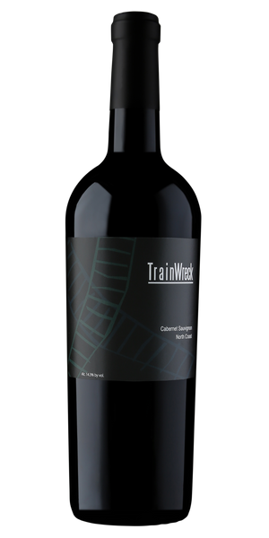
2021 TrainWreck Cabernet Sauvignon

Tasting Notes
This wine is youthful and exuberant and expresses bright Satsuma plum, clove spice and toasted oak characteristics. In the mouth, it is ripe and full bodied and has loads of blue fruits such as plum, blueberry jam, crushed hazelnuts, vanilla bean and cedar box. It has grainy, soft tannins and is approachable now with slight aeration in the glass or in a decanter. This wine works well with a variety of hearty dishes from Bloody Mary marinated tri-tip roasts and hand-rubbed rack of ribs to Cabot Cheddar Cheese and chocolate mousse cake. It will age well for up to a decade, but feel free to enjoy it this evening with family and friends!
Vineyard & Winemaking
The 2021 vintage began with some rain in January and February and almost nothing after that. A relative ‘drought’ year, saw mild weather through spring and summer and an early start to harvest. 2021 was one of the lightest and most concentrated in recent past vintages. The North Coast in California is home to some of the greatest wines produced in the world and this wine, although humble, is a great example of North Coast viticulture and winemaking. Napa and Sonoma Counties are the genesis of this delicious and affordable Cabernet. The alluvial soils, well-drained and with some slope to keep the root systems dry, are an excellent place to grow fine Cabernet Sauvignon.
Technical Details
Brix at Harvest: 25.2
Finished pH: 3.51
Finished TA: 0.62
Varietal: 100% Cabernet Sauvignon
Vineyard Locations: North Coast California

