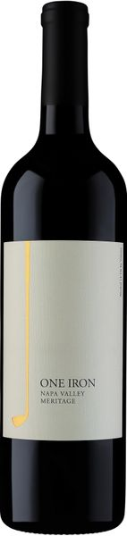
2021 One Iron Meritage

Tasting Notes
If you have ever taken the leap of faith to start playing golf, you may have found out that the 1-iron golf club is near impossible to swing. Lucky for you, the 1-Iron Meritage Blend (our “weekday wine” as we call it) will have you remembering why good wine is so easy to drink, instead of thinking about divot-filled iron shots. The 2021 1-Iron explodes on the nose with muddled Bing cherries, cracked wheat toast and violet, while a bright red-fruit entry on the tongue soon gives way to an exuberant middle and silky-smooth finish. This mesmerizing blend of Merlot, Cabernet Sauvignon and Malbec will be sure to delight at BBQ’s, pizza nights and steak houses everywhere.
Winemaking
Hand picked grapes were rushed to the winery on a cool morning and immediately sorted and destemmed to small stainless steel tanks. The wine was fermented for a total maceration period of 28 days. After fermentation, the wine was racked to small, French and American oak barrels to allow mellowing and to develop complexity over the 26 month aging period.
Vineyard
We sourced the fruit from some outstanding vineyards in Napa Valley. Merlot, Cabernet Sauvignon and Malbec were artfully blended to make this wine full-bodied, delicious and age worthy.
Technical Details
Brix at Harvest: 23.8, 24.5, 25.1
Finished pH: 3.49
Finished TA: 0.62
Varietals: 69% Merlot, 25% Cab Sauvignon, 6% Malbec
Vineyard Locations: Upper Napa Valley

