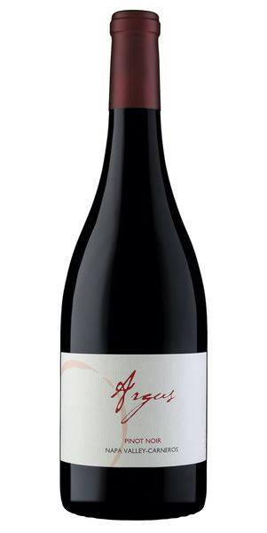
2021 Argus Pinot Noir

Tasting Notes
This is our 13th release of Argus Pinot noir and is every bit as delightful as each of the previous vintages. Dark-ruby in color, it is loaded with ripe fruit, spice and savory, mouth-watering Los Carneros Pinot characteristics, including juicy cherry and fresh cranberry. Pinot noir is extremely versatile and it will be an excellent accompaniment to a variety of dishes that require a wine that has perfume, ripe red fruits, a mid-palate of length and a long, lingering finish of refined power. Enjoy on all occasions great and humble.
Winemaking
Pinot noir, more than any other varietal, benefits from extreme gentle handling (hand sorting, gentle destemming, and manual punch downs) during the fermentation help to make this fickle grape taste great. This wine was treated with the utmost respect throughout harvest, aging and bottling. The predominate clone of Pinot used for this wine is 115, which has been sourced from one of the finest vineyards in the Cote de Nuit, Burgundy. It produces a dark-colored Pinot noir that has both elegance and depth.
Vineyard
The Los Carneros appellation in the southern part of Napa Valley is known for producing Pinot noir and Chardonnay with vibrant aromas and flavors as well as subtle nuance. The proximity to the San Pablo/San Francisco Bay is convenient to the region for moderating heat and cold throughout the year. It is typically up to 20 degrees cooler than the Northern part of Napa Valley during the summer and early fall months. The temperature, coupled with the high calcium content of the soil provides an excellent terroir with which to craft fine wines.
Technical Details
Brix at Harvest: 24.1
Finished pH: 3.78
Finished TA: 5.70
Varietal: 100% Pinot Noir
Vineyard Location: Los Carneros, Napa Valley

