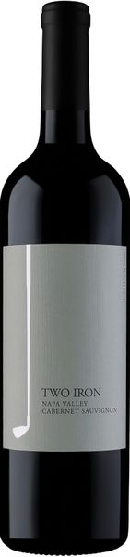

2020 Two Iron Cabernet Sauvignon

Technical Details
Brix at Harvest: 24.7 & 25.2
Finished pH: 3.58
Finished TA: 0.62 g/100 ml
Varietal: 97% Cabernet Sauvignon & 3% Merlot
Vineyard Locations: Upper Napa Valley
Tasting Notes
The Iron-Series wines were born out of a love, and not necessarily a talent for golf. This 2020 2-Iron Cabernet Sauvignon will surely show you that we spend much more time making delicious wines than we do practicing our swings. These flavor-packed grapes are hand harvested every year with extreme care, and the resulting wine we can craft fully represents the terroir. The essence of boysenberry, rhubarb, and lilac dazzles on the nose, meanwhile cacao powder, brown sugar and vibrant fruit carry a brightness through every sip. Enjoy on the course or at home with friends!
Winemaking
These beautiful grapes were hand-picked and sorted before being gently destemmed. Fermentation occurred in small stainless steel tanks. After fermentation, the wine was racked to small, French and American oak barrels to allow mellowing and complexity. It is a blend of 97% Cabernet Sauvignon from select sites in mostly upvalley vineyards and 3% Merlot. The Merlot adds lively fruit and balance to this otherwise tannic, big-boy of a wine.

