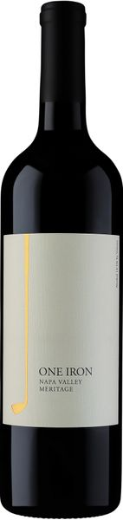
2020 One Iron Meritage

Tasting Notes
Meritage is a term used to describe wines made from the Bordeaux varietals in California. This delicious blend of Cabernet Sauvignon, Merlot and Malbec will rival any big red you will find at twice the price. It will pair with duck, and soft bleu cheese in addition to a host of other flavors and combinations. It will age well for a decade or more but is drinking beautifully now with slight aeration.
Vineyard & Winemaking
2020 gave us a dry winter and coo temperatures not coming in until late spring, with especially cool mornings and consistently warm days in the summer. Although the fall dry season resulted in smaller red wine harvest, these beautiful grapes were hand-picked and sorted before gentle destemming and fermentation in small stainless steel tanks for a total maceration period of 28-35 days. After fermentation, the wine was racked to small, French and American oak barrels to allow mellowing and to develop complexity. We sourced the fruit for our 2020 vintage from some outstanding vineyards in Napa Valley. Merlot, Cabernet Sauvignon and Malbec were artfully blended to make this wine full-bodied, delicious and age worthy.
Technical Details
Brix at Harvest: 24.8 - 25.5
Finished pH: 3.49
Finished TA: 0.57
Varietals: 24% Merlot, 70% Cabernet Sauvignon and 6% Malbec
Vineyard Locations: Napa Valley

