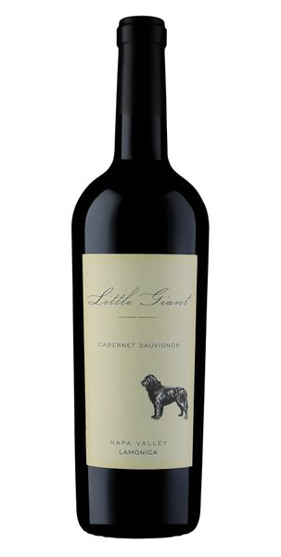
2020 Little Giant Lamonica Cabernet Sauvignon

Winemaking
We hand harvested the fruit then quickly got it to the winery for processing by gently destemming then placing the fruit in tank for cold soaking prior to fermentation. Fermentation proceeded smoothly prior to draining the free run and lightly pressing the skins. The wine was racked to 50% new French oak barrels “dirty” with the light lees intact and then racked five times prior bottling.
Vineyard
Sam Lamonica planted his vineyard in 2002 on the red and gold decomposed granite hillside by his home in the Napa Valley, located just south of the Stags Leap district on a rocky hillside off the Silverado Trail. The well-drained soils produce a small crop that is concentrated and pure. The vineyard was planted to the most highly sought-after cabernet clone 337 which is the basis of the most revered Cabernets of Napa Valley.
Tasting Notes
This is our 10th vintage of Lamonica Cabernet Sauvignon bottled. The 2020 Little Giant Lamonica cabernet is loaded with black fruit, tea leaf, brambles, baking spices and high quality oak flavor. It opens with an intense bouquet with black fruits hinting at the rich flavors to come.
Technical Details
Brix at Harvest:24.3
Finished pH: 3.57
Finished TA: 6.36
Varietals: 100% Cabernet Sauvignon
Vineyard Location: Vaca Range, Napa Valley

