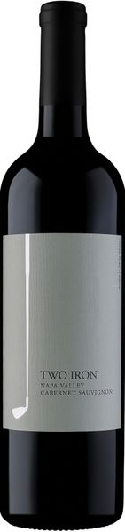
2019 Two Iron Cabernet Sauvignon

Tasting Notes
The Iron-Series wines were born out of a love, and not necessarily a talent for golf. This 2019 2-Iron Cabernet Sauvignon will surely show you that we spend much more time making delicious wines than we do practicing our swings. This is a wine with substance and power. It can pair well with beef, lamb and chocolate. Bright red and blue fruit along with a full-midpalate and long lingering finish are hallmarks of this bold and ageworthy wine. Enjoy on the course or at home with friends!
Winemaking
The 2019 growing season was a beautiful thing for winemakers. Small crop and high quality character typified the vintage. The 2019 Two Iron Cab grapes were sourced from several upper valley vineyards and treated gently and carefully during their journey to tank, barrel and bottle. The wine is a blend of 93% Cabernet Sauvignon and 7% Merlot. The Merlot adds a brightness and balance to this densely packed wine.
Technical Details
Brix at Harvest: 25.4 & 25.9
Finished pH: 3.64
Finished TA: 0.59 g/100 ml
Varietal: 93% Cabernet Sauvignon & 7% Merlot
Vineyard Locations: Upper Napa Valley

