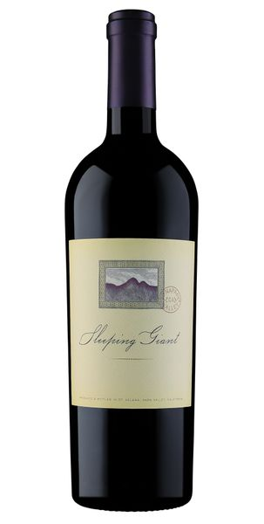
2019 Sleeping Giant Cabernet Sauvignon, Oakville

Tasting Notes
Our second vintage of Oakville Cabernet has notes of Bing cherry, hints of sarsaparilla, baking spices, and vanilla. It is a dense, highly concentrated wine with loads of aromatic characteristics and a palate of fruit, depth and length that will evolve and continue to unwind over time.
Winemaking
The 2019 vintage was the first ‘cooler’ vintage of the last five. Moderate rainfall, a slightly delayed budbreak and long, cool, growing season with few heat spikes allowed even ripening of the berries on the clusters. An unusually leisurely harvest season ensued and winemakers were able to harvest at optimum ripeness and maturity. The grapes in 2018 were cold-soaked for 6 days prior to inoculation and fermentation of the must that macerated for almost 26 days on the skins. The must was then lightly pressed and separated and placed into 100% new, tight-grained French oak (Chateau Ferre) barrels for over 26 months and was racked six times for clarity and freshness before bottling.
Vineyard
Oakville is one of the premiere growing regions in the Napa Valley for Cabernet Sauvignon. The soil, orientation of vineyard rows and climate are some of the reasons why this small appellation is home to some of the most sought-after Cabernets in Napa Valley.
Technical Details
Brix at Harvest: 24.4
Finished pH: 3.56
Finished TA: 6.38
Varietal: 100% Cabernet Sauvignon
Vineyard Location: Oakville

