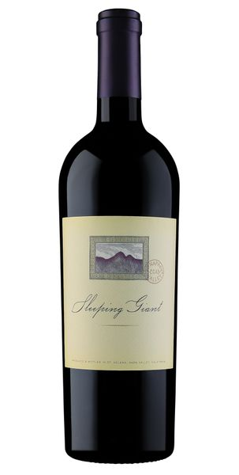

2019 Sleeping Giant Cabernet Sauvignon, Coombsville

Tasting Notes
This wine is deep and rich, with essence of blueberry, lychee, spice, and a hint of cocoa powder, and fresh baked bread. It is an elegant wine with refined tannins and structure, the epitome of Cabernet Sauvignon from the 16th appellation of Napa Valley.
Vineyard & Winemaking
2019 was another outstanding vintage! We started with copious amounts of rainfall early in the season, followed by an even summer with few heat spikes. This vintage has been produced from the newest and 16th appellation in Napa Valley - Coombsville. The fruit was hand harvested and rushed to the winery where it was destemmed into a small, open topped fermenter. It fermented on the skins to extract all the color and flavor possible. It was lightly pressed and then placed in small, French oak barrels for aging.
Technical Details
Brix at Harvest: 24.1
Finished pH: 3.84
Finished TA: 5.88
Varietal: Cabernet Sauvignon
Vineyard Location: Coombsville, Napa Valley

